Sprint-6  
  
**1. Applicant’s full details (Epic)**To view all the details of an applicant sourced from resume, screening questions and also to schedule an interview, share an email. Hence, all the actions related to an applicant are to be included in this screen itself.  
**1.1 Applicant details layout and key details (Story)**

Description:  
All the details of an applicant and all the necessary actions by a recruiter for an applicant should take place in one place.  
Acceptance Criteria:  
à Once a recruiter selects an applicant’s card from Applicant’s page of any particular job or from All Applicants’ page, then the user has to be taken to Applicant’s full details page.  
à This page should consist of:  
i. Key details card  
ii. A horizontal navigation menu  
iii. Full details of each option in menu  
iv. Feedback (Hidden for MVP-1)  
v. CTAs  
à On top of this page, a back button should be included followed by the title of this page as “Applicants”  
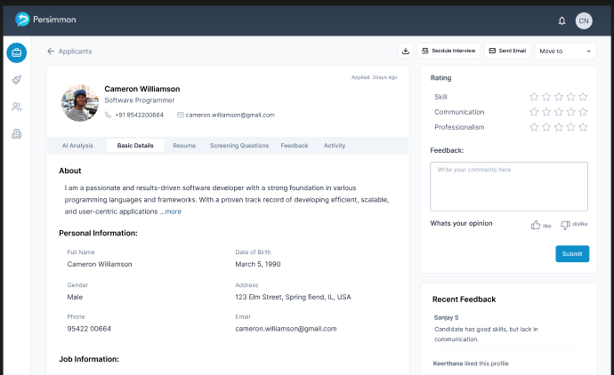  
  
i. Key details:  
--> In this card, the picture of the applicant, followed by Name, Linked URL (as an image with URL as hyperlink), designation, mobile number and email address should be included.   
--> On the top right corner of this card, the date of application submission or date of importing the resume should be included.  
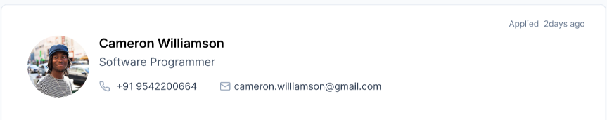  
--> If the applicant’s details (resume or from screening questions) doesn’t contain an image, then a dummy image should be included. Here’s the image to be used:  
  
--> If the applicant’s details (resume or from screening questions) doesn’t contain LinkedIn URL, then LinkedIn logo is to be hidden. Hence, the logo only appears for applicants with LinkedIn URL.  
--> Mobile number and Email ID should be fetched from the resume of an applicant.  
  
ii. Horizontal navigation menu:  
--> There should be a horizontal navigation menu included for a user.  
--> This menu should consist of,   
-AI Analysis (Hidden for MVP-1)  
-Basic Details  
-Resume  
-Screening Questions (Hidden for MVP-1)  
-Feedback (Hidden for MVP-1)  
-Activity (Hidden for MVP-1)

--> Which ever option the user chooses, the details of that menu option should appear below the menu.  
  
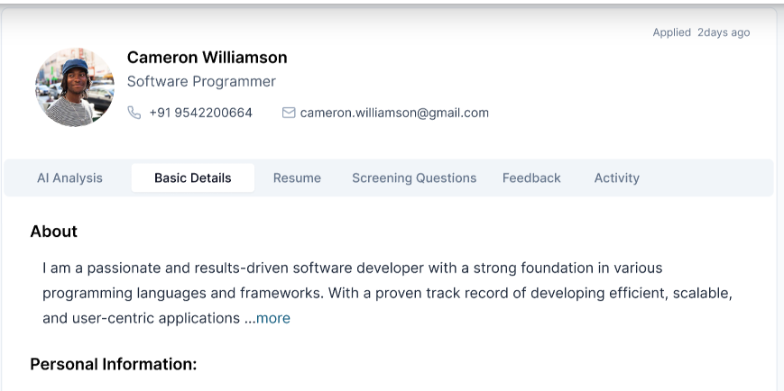  
  
1.2. **Basic Details (Story)**Description:  
All the basic details of an applicant should be included in this menu option.  
Acceptance Criteria:  
--> Once a user selects “Basic Details” option from the horizontal navigation menu, all the details of an applicant (from both resume and AI screening questions) should appear.

--> This card should include:  
i. About:  
This information is to be fetched from Resume (Profile summary)  
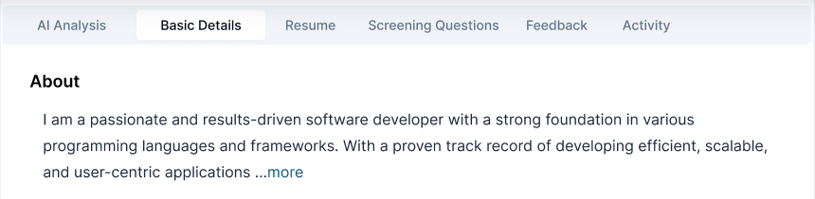  
ii. Personal information:  
This should consist of   
- Full name (from Resume)  
- Email ID (from resume)  
- Gender (from AI screening questions)  
- Address (from resume or AI screening questions)  
- Date of birth (from resume or AI screening questions)   
--> If any these details aren’t available in Resume, “N/A“ is to be placed.  
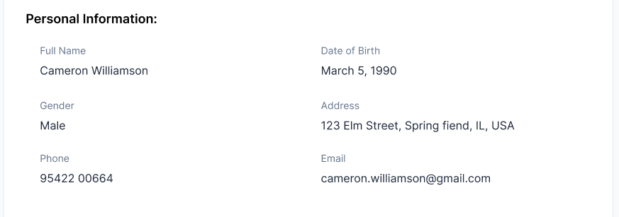  
  
iii. Job information:  
This should consist of  
-Job title (from resume or AI screening questions)   
-Department (from resume or AI screening questions)   
-Current organization (from resume or AI screening questions)   
-Work experience (from resume or AI screening questions)  
-Job location (from resume or AI screening questions)   
-Preferred Job location (from AI screening questions-MVP-2)   
-Current CTC (from AI screening questions-MVP-2)   
-Expected CTC (from AI screening questions-MVP-2)  
-Skills (from resume or AI screening questions)   
  
--> If the details are available in Resume, then the data is to be displayed. Else, as we don’t have the AI screening questions in MVP-1, we need to display “N/A“ in the place of data.  
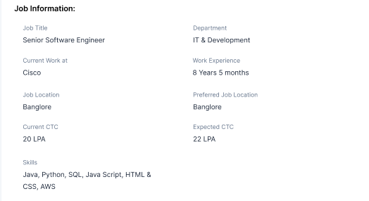  
  
  
iv. Social media:  
--> This should include  
-LinkedIn profile URL (from resume or AI screening questions)   
-GitHub URL(from resume or AI screening questions)   
-Instagram URL (from resume or AI screening questions)   
-Facebook URL (from resume or AI screening questions)   
--> If the details are available in Resume, then the data is to be displayed. Else, as we don’t have the AI screening questions in MVP-1, we need to display “N/A“ in the place of data.  
  
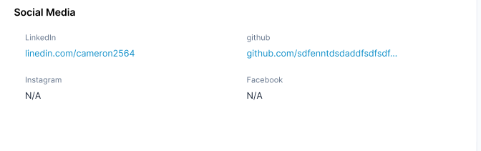  
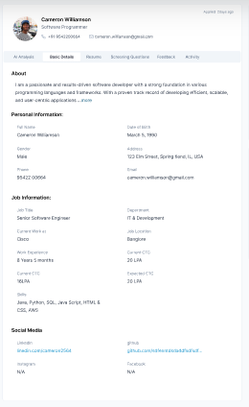  
  
  
  
**1.3 Resume (Story)**  
Description:  
The resume of an applicant is to be displayed in this page.  
Acceptance Criteria:  
--> Once a user selects Resume from the Horizontal navigation menu, the resume of that applicant should be displayed on the screen.   
--> A download option is also provided for the user to download that resume as a PDF.  
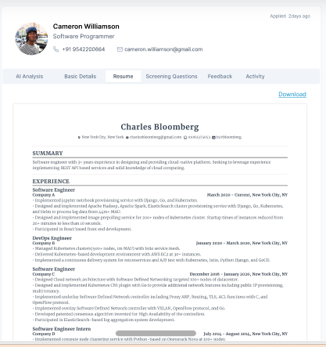  
--> Once a user selects the Download button, the resume should be downloaded as a PDF with naming as “Persimmon_Firstname_Resume.PDF”

**1.4 CTCs (Task)**--> The “Move to” button should be included at the top right corner of the Applicant’s full details page.  
--> This button should have all the functionalities of “Move to” in the All Applicants’ page. Hence, this is just a copy of it.  
--> Beside this button, there should be:  
-Send email  
-Schedule interview  
-Download  
are to be provided for the user. However, all these three are to be hidden in the UI as we’ll be having these in MVP-2.  
  
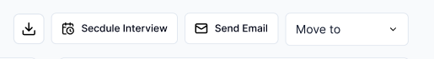  
**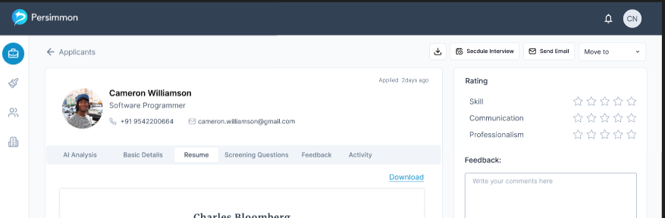  
  
2. Integrations (Epic)**To integrate the user’s organization’s career page and Email with Persimmon.

**2.1 Integrations Page (Task)**  
--> The existing menu should include the Integrations icon (plug icon), which should be placed between All jobs and All applicants’ icon.  
--> Once a user selects this icon, then the user should be taken to integrations page.  
--> For this MVP, we are only having Career page.  
  
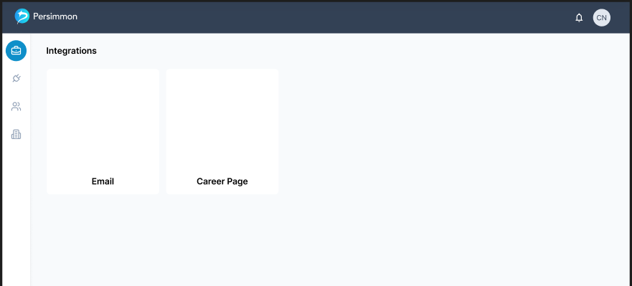Note: A logo will be added in the Career page thumbnail by Siva.  
  
Note: Kindly ignore Email as it’s just for the reference. Hence, the only integration will be having is Career page and it’s position should be aligned accordingly.  
  
**2.2 Career Page layout (Story)**  
Description:  
As a recruiter, I’d like to integrate my organization’s career page with persimmon such that all the jobs I wish to publish on career page through persimmon is possible.  
Acceptance criteria:  
--> Once a user selects the “Career page” thumbnail in the Integrations page, the user should be taken to “Career Page Integration” page.  
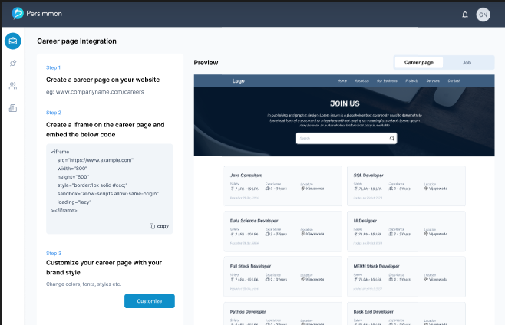  
  
--> In this page, to the left side of the screen, procedure should be included.  
These steps should consist of:  
i. Step-1:  
A title as “Create a career page on your website” followed by sub title as “ex: www.companyname.com/careers”  
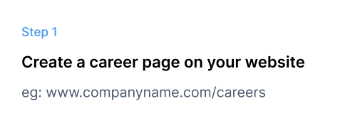  
  
ii. Step-2:  
Title as “Create an i-frame on your career page and embed below code” followed by a text box (Non-editable) with copy button to copy the code inside the text field  
-This field should consist of Career page URL and Job page URL created by persimmon for that recruiter along with other parameters -These parameters are to be decided by Venkat

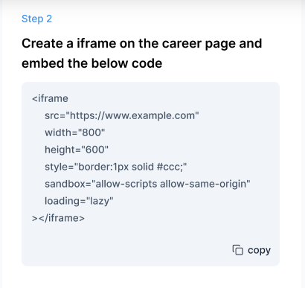  
  
iii. Step-3:  
Title as “Customize your career page with your brand style” followed by a sub title “Change colors, font style, Image etc.”  
Followed by a CTA “Customize” (primary button)  
--> To the right side, the preview window should be available for the user.  
--> On top of this Preview window, an option to select either career page or job has to be provided for the user.  
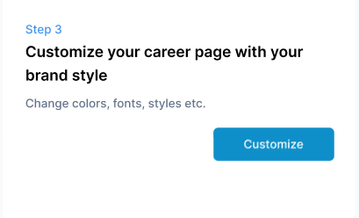  
  
**2.3 Career page UI (Story)**

Description:  
As a recruiter, I’d like to see all the jobs published by me using Persimmon on my organization’s career page.  
Acceptance Criteria:  
--> This page is unique for every recruiter. However, by default, the layout is to be the same.  
--> This entire page is customizable for the user in the Career page settings page.  
--> This page should consist of a header stating the contents of it. Such as:  
i. Logo,  
ii. Home  
iii. About us  
iv. Our business  
v. Projects  
vi. Services  
vii. Contact us.  
--> Note: This header is only to be displayed in the preview screen. Thus, in the i-frame (on the career page of recruiter), this header is to be removed and layout should be adjusted accordingly.  
--> Below the header, a cover image should be displayed.   
--> In this cover image, the title should be included stating “join Us” followed by description “Explore opportunities that empower you to grow, innovate, and make an impact. Join a team where your talents are valued, your ideas are heard, and your career aspirations become a reality. Let’s build the future together!” and then a search bar.   
--> This search bar should search the contents inside the i-frame. Which includes Job title and Location.  
--> Below these contents, all the jobs posted by that recruiter are to be displayed as cards.  
--> Each job card should consist of:  
i. Job title  
ii. Salary  
iii. Experience  
iv. Location  
v. Posted on date  
Note: All the active jobs are only to be displayed here.  
--> If the user hasn’t posted any jobs, then in the career page (i-frame), in the place of job cards, the title “**"**Exciting Opportunities Ahead!" followed by “We don’t have any active job openings right now, but we’re always planning for the future. Stay connected with us and be the first to know about upcoming roles.” should be placed.  
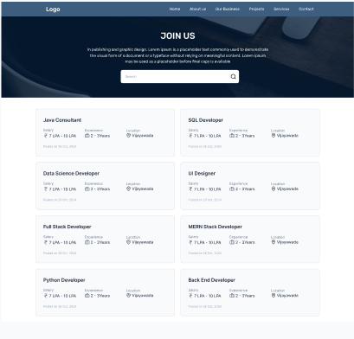  
  
 **2.4 Career page-Job page (Story)**

Description:  
As a recruiter I’d like to see a particular job published by me using Persimmon on my organization’s career page.  
Acceptance Criteria:  
--> This page is unique for every recruiter. However, by default, the layout is to be the same.  
--> This entire page is customizable for the user in the Career page settings page.  
--> This page should consist of a header stating the contents of it. Such as:  
i. Logo,  
ii. Home  
iii. About us  
iv. Our business  
v. Projects  
vi. Services  
vii. Contact us.  
--> Note: This header is only to be displayed in the preview screen. Thus, in the i-frame (on the career page of recruiter), this header is to be removed and layout should be adjusted accordingly.  
--> Below the header, there should be 4 sections to display. The first section should include:  
i. Job ID  
ii. Job title  
iii. Location  
iv. Job type  
v. Workplace type  
vi. Apply now (as a CTA)  
vii. A back icon (placed on top of the key details card)  
-On clicking this back icon, the user should be taken to all jobs page.  
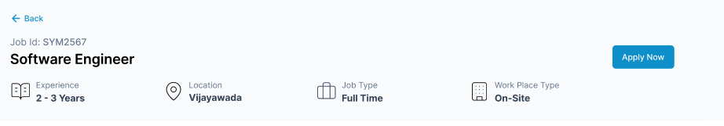  
--> The second section should be placed below the Job key details section but to the left side of the screen. This should include the Job description of that job.  
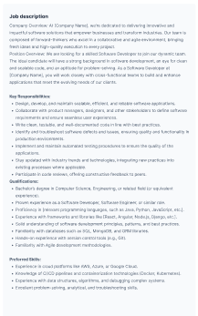  
--> The third section should also be placed below the Job key details page but to the right side of the screen.  
--> This section should include All the other jobs posted by that recruiter. (the limit to display in this card is 5 jobs only)  
-The title of this section should be “All jobs” followed by other job posts with Job title, Location, Salary, Job type & workplace type as details for job.  
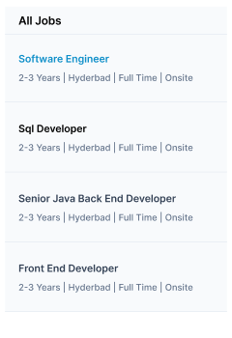  
--> The last section should consist of a form.  
- The title (to place above this section) should be “Apply for the Job”.  
- This form should include:  
i. Mobile number (as input field)  
-The validations are to be same as Mobile number field in the Recruiter’s sign up page.  
ii. Send OTP (as button/CTA)  
-This should only enabled after the user enters a valid Mobile number  
-Service to share OTP is to be decided by Venkat.  
iii. Enter OTP (as input field)  
-This field only appears when an applicant enters a valid Mobile number and Selecting Send OTP button.  
iv. Resend OTP (as a Hyperlink button)  
v. Verify (as a button/CTA)  
-This should enable after a user enters valid number of characters in the enter OTP field.  
-If the user enters incorrect OTP, then the error message to display should be “Enter a valid OTP”. Same for expired OTP too.  
-If the user enters a valid OTP, then Send OTP, enter OTP field, resend OTP, verify buttons are to replaced by a tick mark inside the Mobile number field and a text below the Phone number field as “Mobile number verified successfully”  
vi. Full name (as input field)  
-Only alphabets are to be accepted in this field.  
-If the user enters any special character except full stop and space, then the error message should be “Enter a valid name”. Same for two consecutive spaces or full stops.  
-The maximum characters allowed are 25.  
vii. Email ID (as input field) (Format: local part + domain)  
-The domain should be either:   
@gmail.com,   
@outlook.com,   
@yahoo.com,   
@icloud.com,   
@protonmail.com,   
@proton.me,   
@gmx.com,   
@mail.ru,   
@yandex.com,  
@yandex.ru,  
@zoho.com,  
@aol.com,  
@mail.com,  
@consultant.com,  
@teacher.com  
-If the user enters any other domain, then the error message to display should be “Enter a valid email ID”  
-The local part should accept:  
a-z  
A-Z  
.  
-  
%  
+  
0-9  
-If the user enters any other characters, then the error message to display should be “Enter a valid email ID”  
viii. LinkedIn profile (as input field)  
-The validations should be same as LinkedIn URL field in Recruiter’s details page.  
  
ix. Resume (Browse files to select)  
-The validations are same as Import files functionality in Applicants page of a job for a Recruiter.  
  
x. Submit (as a button/CTA)  
-This is to be enabled only after a user fills all the fields with valid data. Thus, all the field are to be mandatory.

Xi. A captcha service should also be provided for the user between resume and Submit buttons (not included in Figma but must implement). Here’s the reference link for Captcha service: https://www.google.com/recaptcha/about/  
  
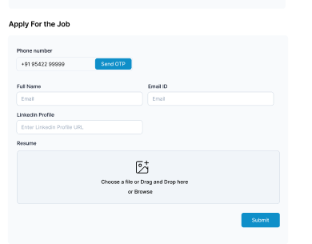  
  
--> Once a user submits the application successfully, except for the Job key details section, all the other sections are to be replaced with :  
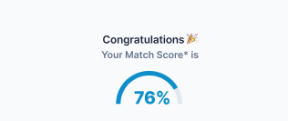  
  
Text “Congratulations *(celebrations emoji)*” followed by “Your match score is” and the match percentage.  
--> This match percentage is based on the Resume details matching with the job description.  
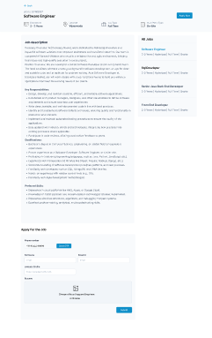  
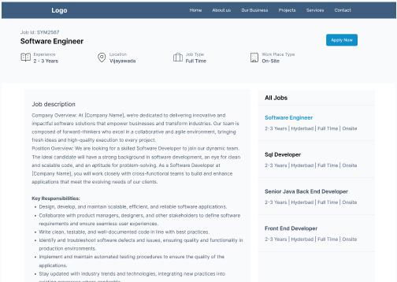  
Note: Include a back icon on top, in the above image.  
  
**2.5 Career page settings (Story)**  
Description:  
As a recruiter, I’d like to be able to customize the look and feel including the contents of Persimmon’s integration into Career page.

Acceptance Criteria:  
--> Once the user selects “Customize” button in the Career page integration page, the user should be taken to “Customize Design” page.  
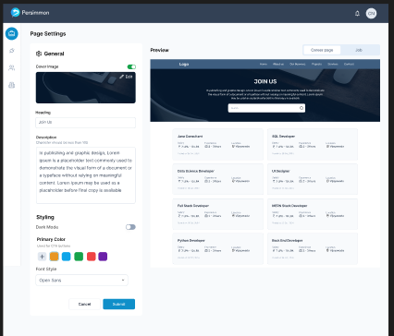  
  
--> In this page, to the left side of the screen, all the settings should be available for the user.  
--> To the right side, the preview window should be available for the user.  
--> On top of this Preview window, an option to select either career page or job has to be provided for the user.  
--> By default, the career page should be selected.  
--> The layout of Career page and job page has to included here but with dummy data (refer to Figma for dummy job details). These details are to be changed once a user customizes.  
--> The customization should include:  
i. Career page (toggle button)  
-By default, the toggle should be in On position. If the user offs the toggle button.

-An edit icon (pencil icon) to select an image (png or jpg formats only)

ii. Heading (input field)  
-By default “Join Us”  
-This field can accept all the special characters and Alphanumeric values. Minimum 0 and maximum 15 characters are to be accepted.  
  
iii. Description (input field)  
-By default “Explore opportunities that empower you to grow, innovate, and make an impact. Join a team where your talents are valued, your ideas are heard, and your career aspirations become a reality. Let’s build the future together!”.  
- This field can accept all the special characters and Alphanumeric values. Minimum 0 and maximum 250 characters are to be accepted.  
Note: If the user turns off cover photo, then the Title, description fields should be in inactive state and in the preview, entire cover photo area should be removed including search bar. Hence, in the preview, only header and job cards are to be displayed.  
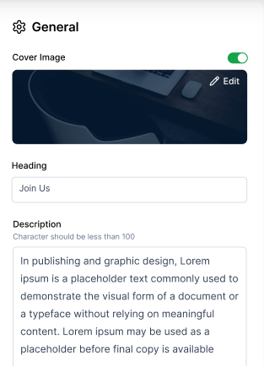  
  
iv. Styling:  
-> Dark mode (toggle switch)  
-By default this should be in Off position.  
-Once the user turns this on, the theme should be changed (cover photo area is to be unchanged)  
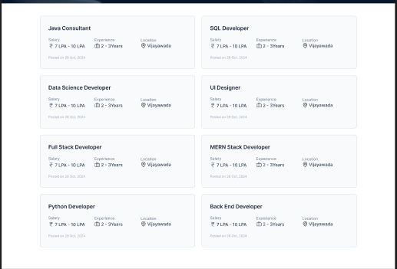  
(Above is the representation of: Dark mode Off)  
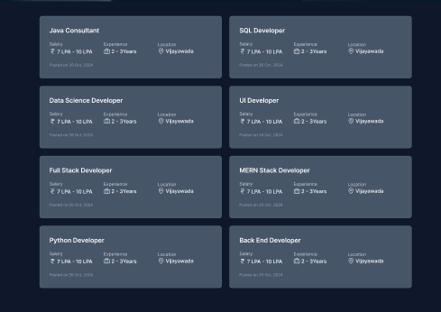  
(Above is the representation of: Dark mode On)  
-The same theme should also be applicable for Job page under career page.  
  
-> Primary Color  
-Followed by “Used for CTA buttons”  
-By default, 5 majorly used colors are to be included and a button to add a new color.  
-Once a user selects this plus icon, then the color selection pallet should open such that a user can select any color as per their wish.  
-Once a new color is added, that has to be included in the colors list.  
-Maximum of 10 colors can be displayed. If the number exceeds, then the old versions (at the right side) should be removed such that new ones push the old to right as they are to be added at the left side.  
-Whichever color the user selects, that should be highlighted with Blue outline with white spacing between the color and outline  
  
Color-1 (selected); Color-2 (non-selected)

-> Font (Dropdown with all the Google fonts)  
-In this dropdown, the name of the font style and example text also should be displayed)  
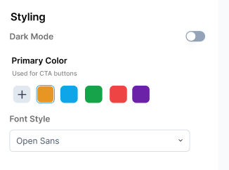  
v. CTA’s  
-> Cancel (secondary button)  
-This is to cancel the action. Once a user selects this, a confirmation box should appear on screen with “Are you sure you want to cancel?” as title and followed by a sub-title “You’ll lose all the current changes” and two CTA’s as “No” which should take the user back to customization screen “Yes” to discard all the changes and the user should be taken to Career page Integration page  
-> Submit (Primary button):  
-Once the user submits the changes, all the modifications are to be reflected in the user’s career page.  
  
  
**3. Log-in and Sign up Pages (Mod) (Task):**  
--> To the right side of the form, the below image is to be included.  
Image to be shared by siva  
  
**4. Create Job page-Company details step (Mod) (Task):**  
--> For the toggle button, text has to be replaced as:  
-If it’s off, the text should be “Posting for self”  
-If it’s On, the text should be “Posting on behalf of Client”  
  
  
 **5. Create Job page-Job key details step (Mod) (Task):**  
àThe field name “Title” should be changed to “Job Title”